AWS EC2 – Docker, Jenkins, Apache, Nginx & Tomcat Installation Assignment
Objective: Launch one Amazon Linux 2 EC2 instance and install Docker, Jenkins, Apache HTTP Server, Nginx, and Apache Tomcat. Include verification commands and screenshot evidence for each task.

1. Launch Amazon Linux 2 EC2 Instance
- Log in to the AWS Management Console.
- Open EC2 → Instances → Launch Instance.
- Set the instance name as DevOps-Assignment-Server.
- Select Amazon Linux 2 AMI.
- Select an appropriate instance type such as t2.medium.
- Select or create an EC2 key pair.
- Configure the Security Group.

Required Security Group Ports
Protocol | Port | Purpose
SSH | 22 | EC2 remote access
HTTP | 80 | Apache/Nginx
Custom TCP | 8080 | Jenkins
Custom TCP | 8081 | Tomcat, if configured on 8081
- Click Launch Instance.
- Wait until the instance state shows Running.
Screenshot Evidence: EC2 instance showing Running state and Security Group rules.
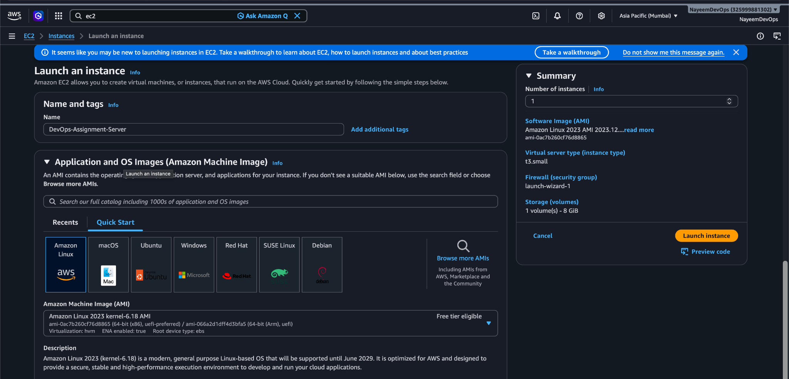
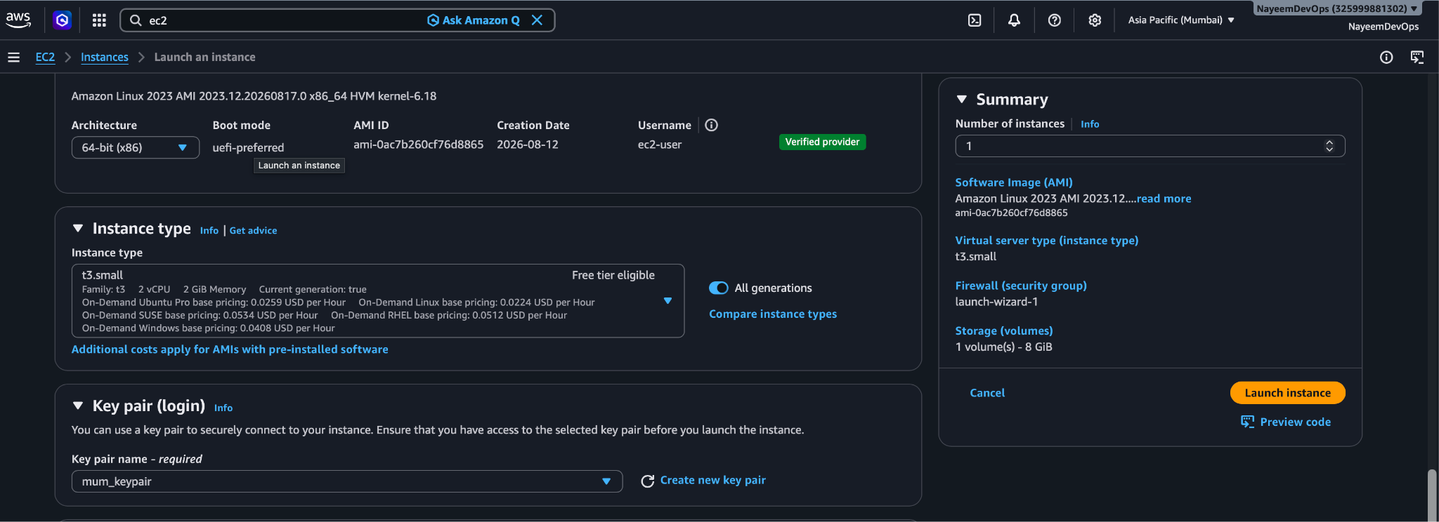
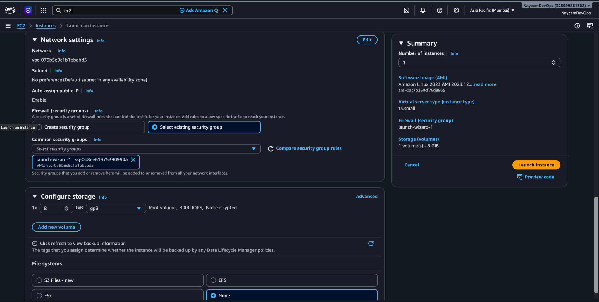
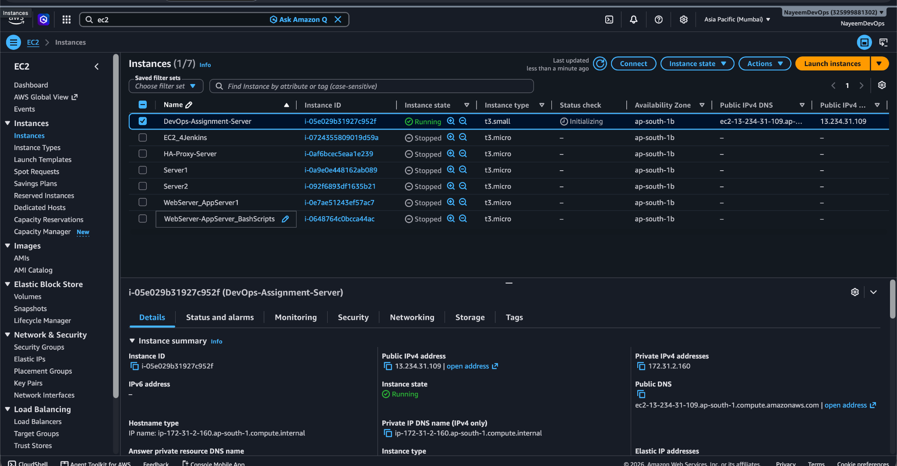

2. Connect to the EC2 Instance
Use SSH:
ssh -i mum_keypair.pem ec2-user@13.234.31.109
Update packages:
sudo yum update -y
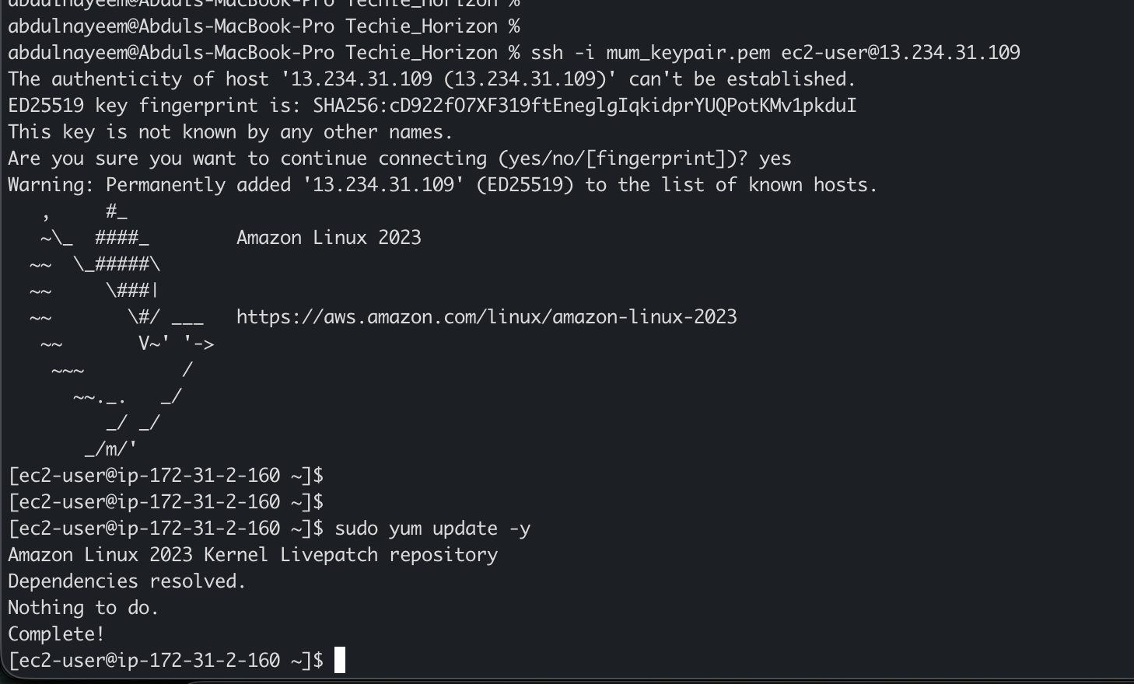

3. Install Docker
sudo yum install docker -y
sudo systemctl enable docker
sudo systemctl start docker
sudo usermod -aG docker ec2-user
Verify:
docker --version
sudo systemctl status docker
Expected Result: Docker version is displayed and the service shows active (running).
Screenshot Evidence: Docker version and service status.
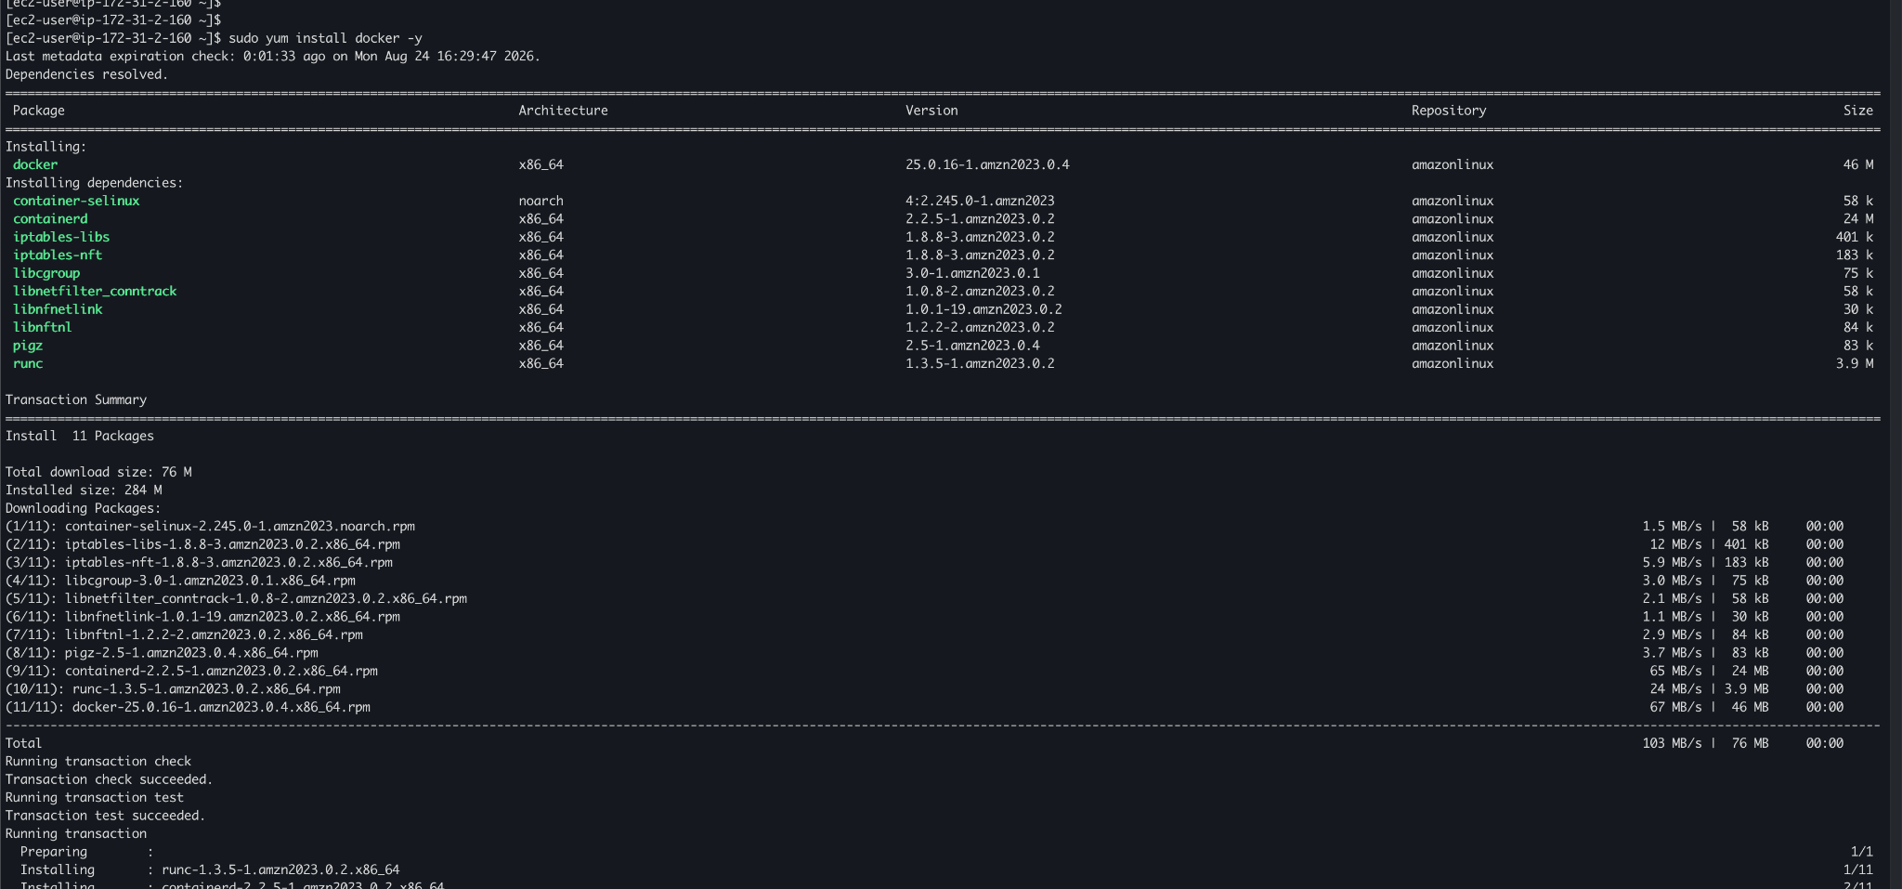
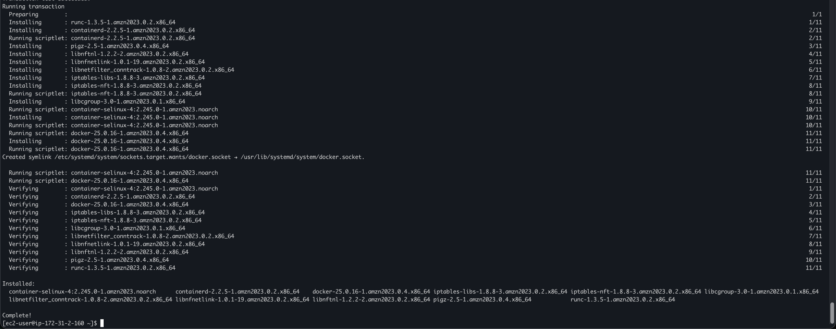
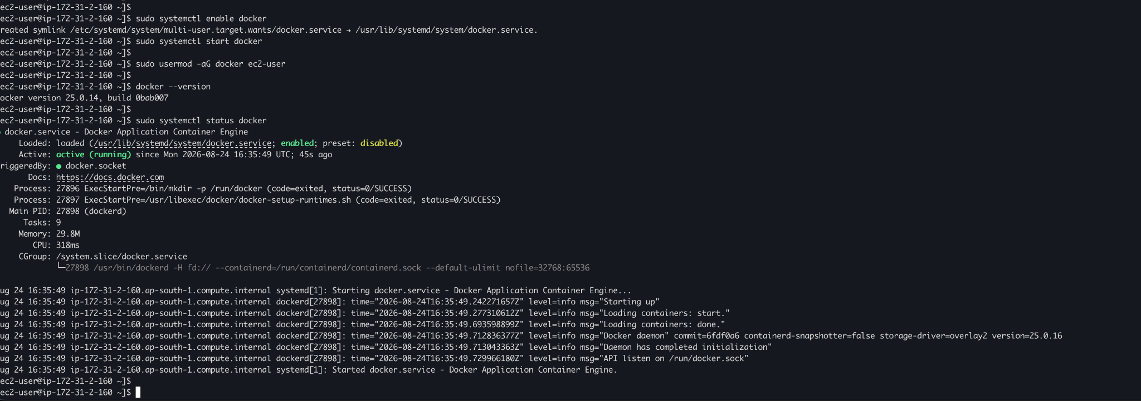

4. Install Java
Java is required for Jenkins and Apache Tomcat.
sudo amazon-linux-extras install java-openjdk11 -y
java -version
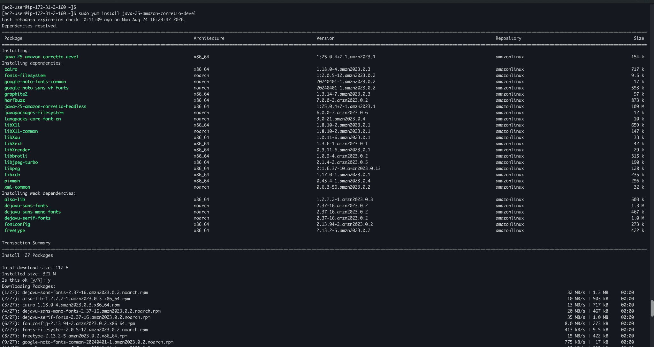
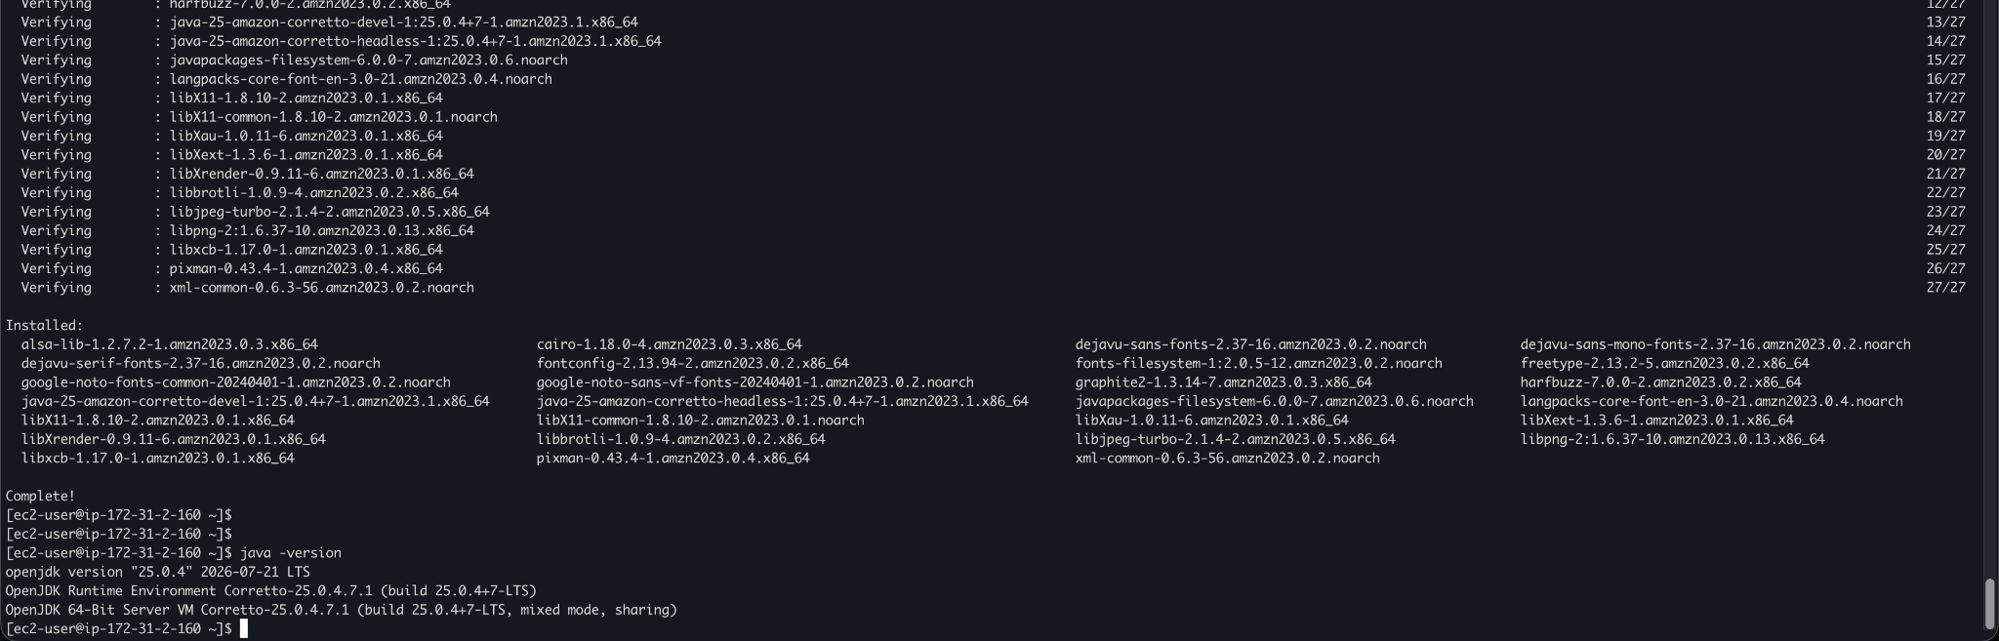
Screenshot Evidence: Java version output.

5. Install Jenkins
Add the Jenkins repository:
sudo wget -O /etc/yum.repos.d/jenkins.repo https://pkg.jenkins.io/redhat-stable/jenkins.repo
Import the Jenkins repository key and install Jenkins:
sudo rpm --import https://pkg.jenkins.io/redhat-stable/jenkins.io-2026.key
sudo yum install jenkins -y
Start Jenkins:
sudo systemctl enable jenkins
sudo systemctl start jenkins
sudo systemctl status jenkins
Retrieve the initial administrator password:
sudo cat /var/lib/jenkins/secrets/initialAdminPassword
Open:
http://<EC2-PUBLIC-IP>:8080
Complete the Jenkins initial setup.
Screenshot Evidence: Jenkins dashboard and Jenkins service status.
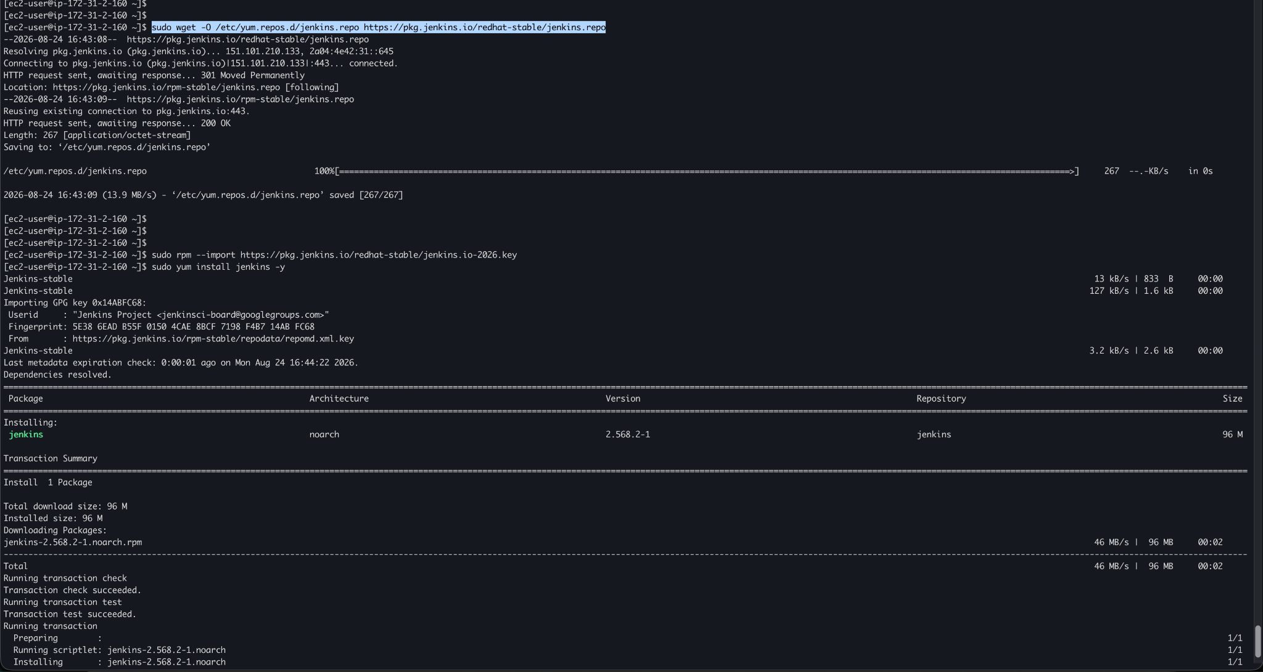
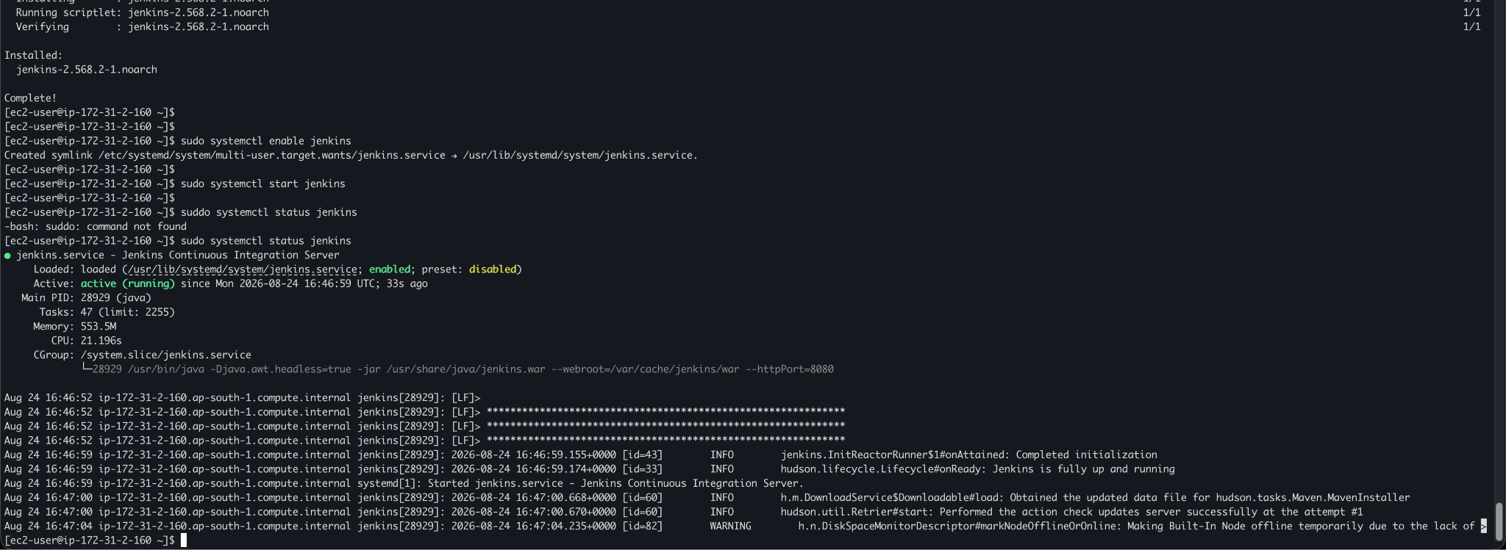
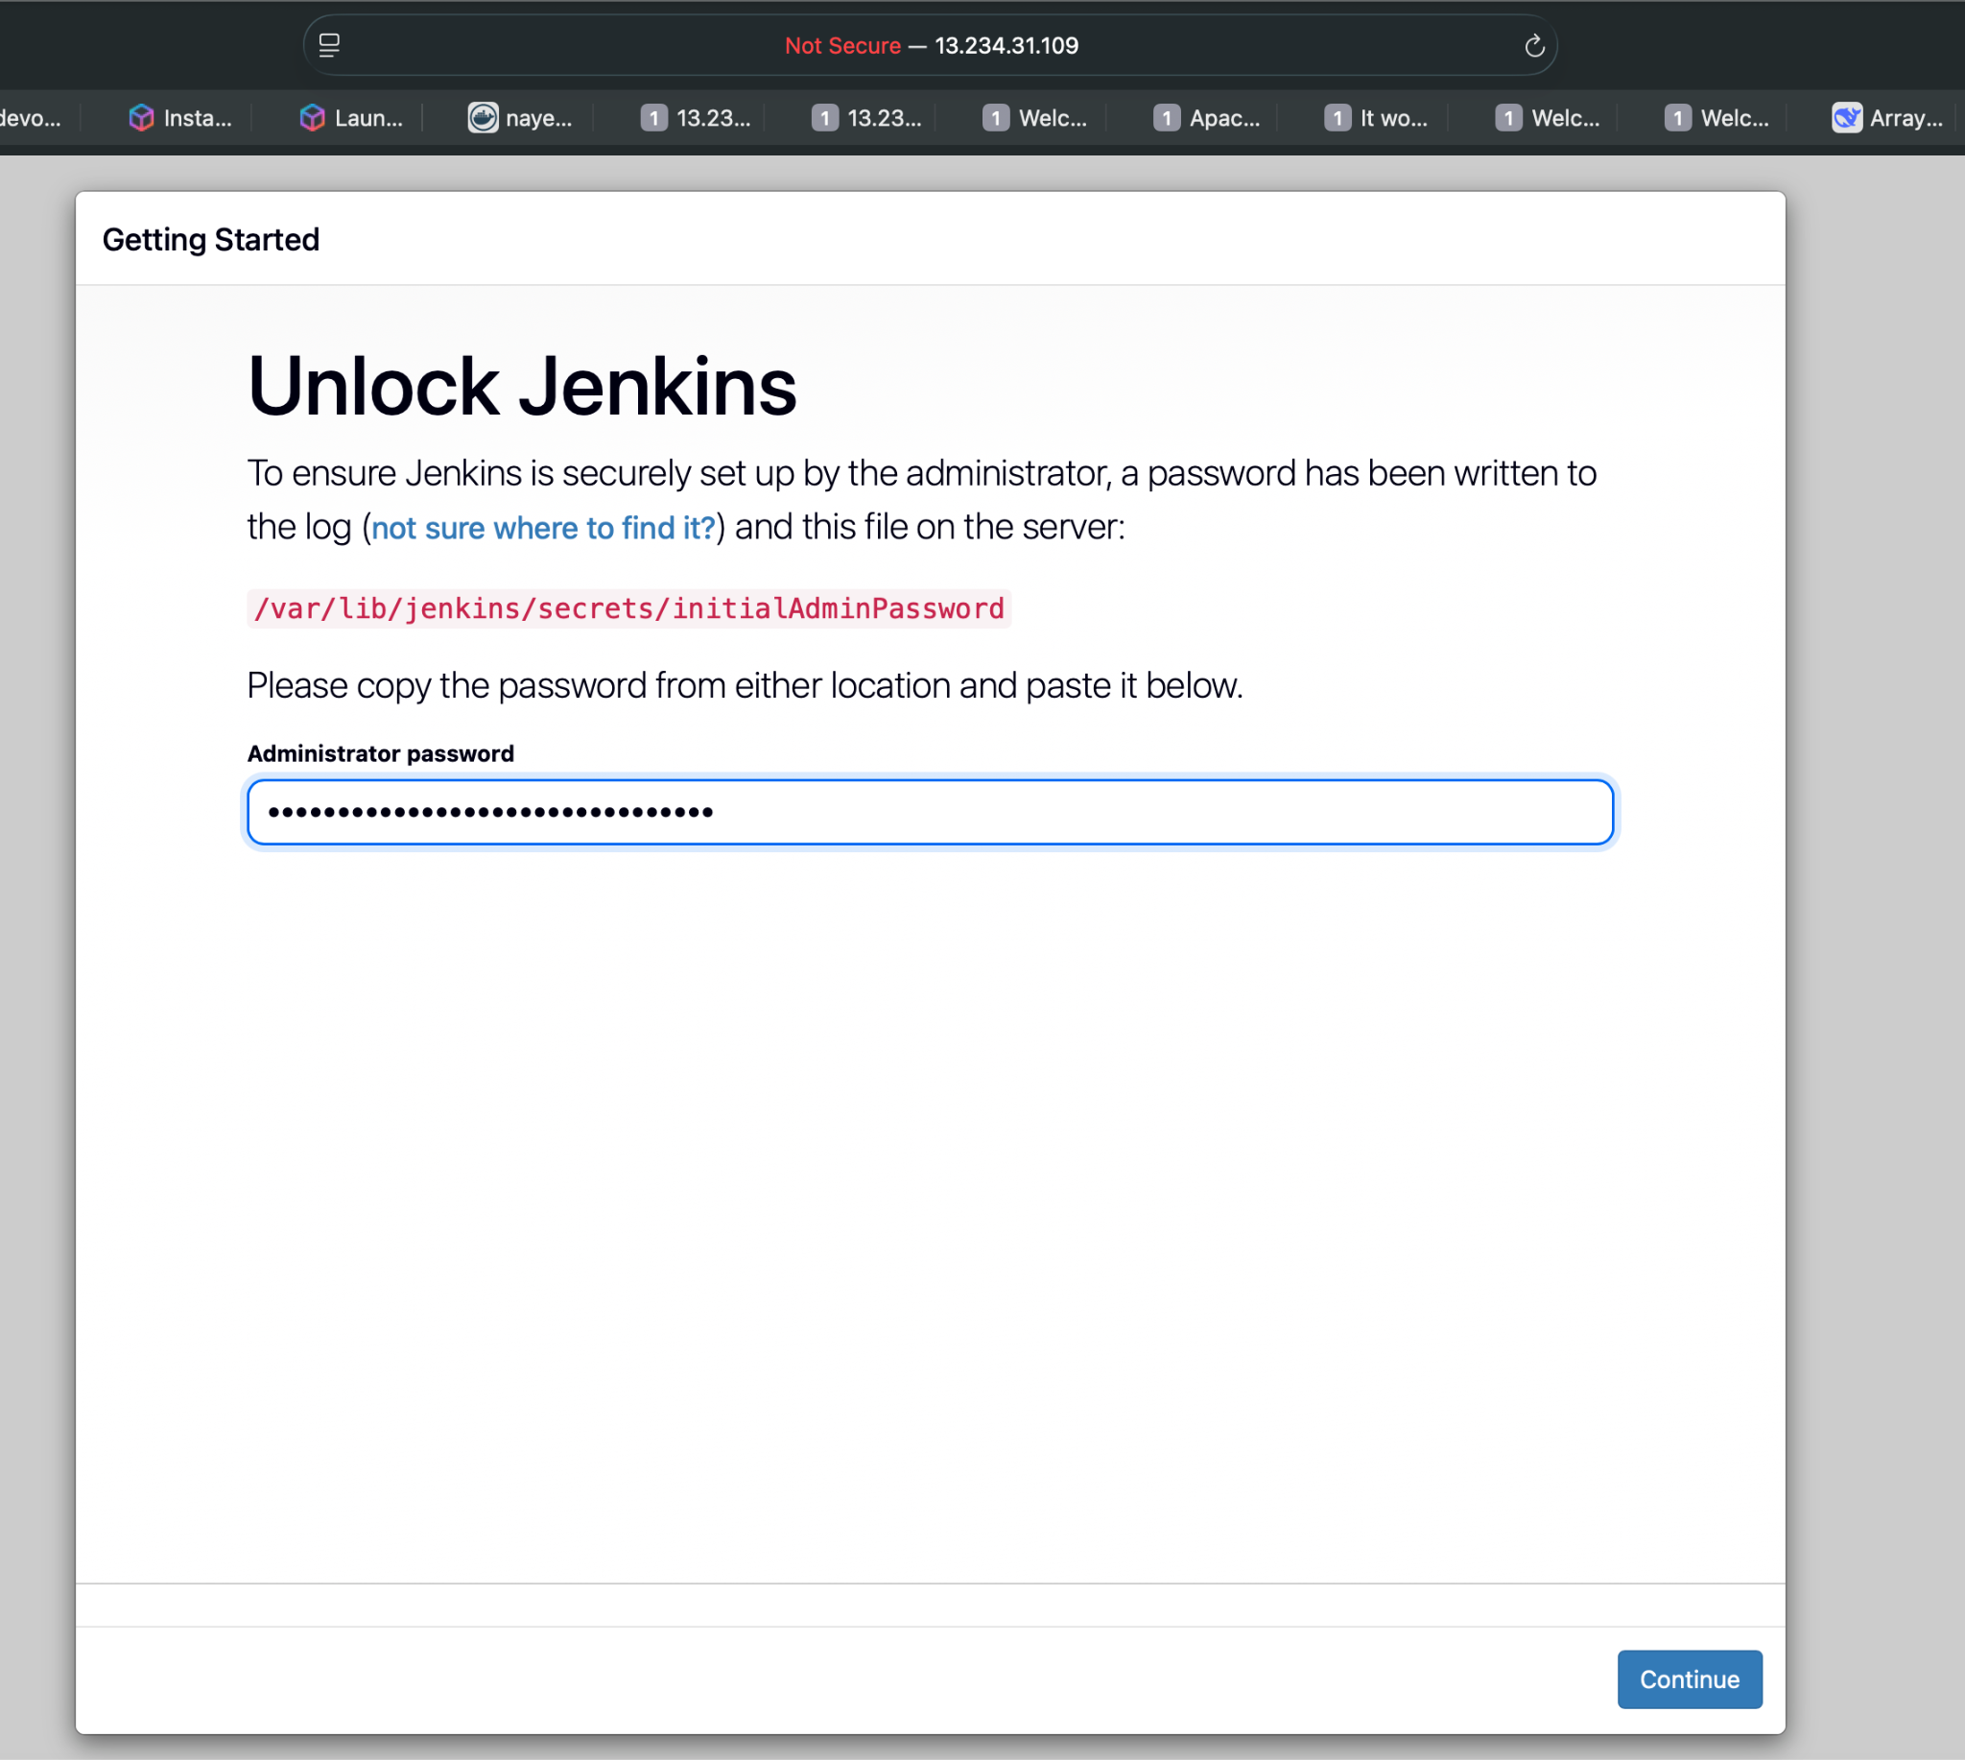
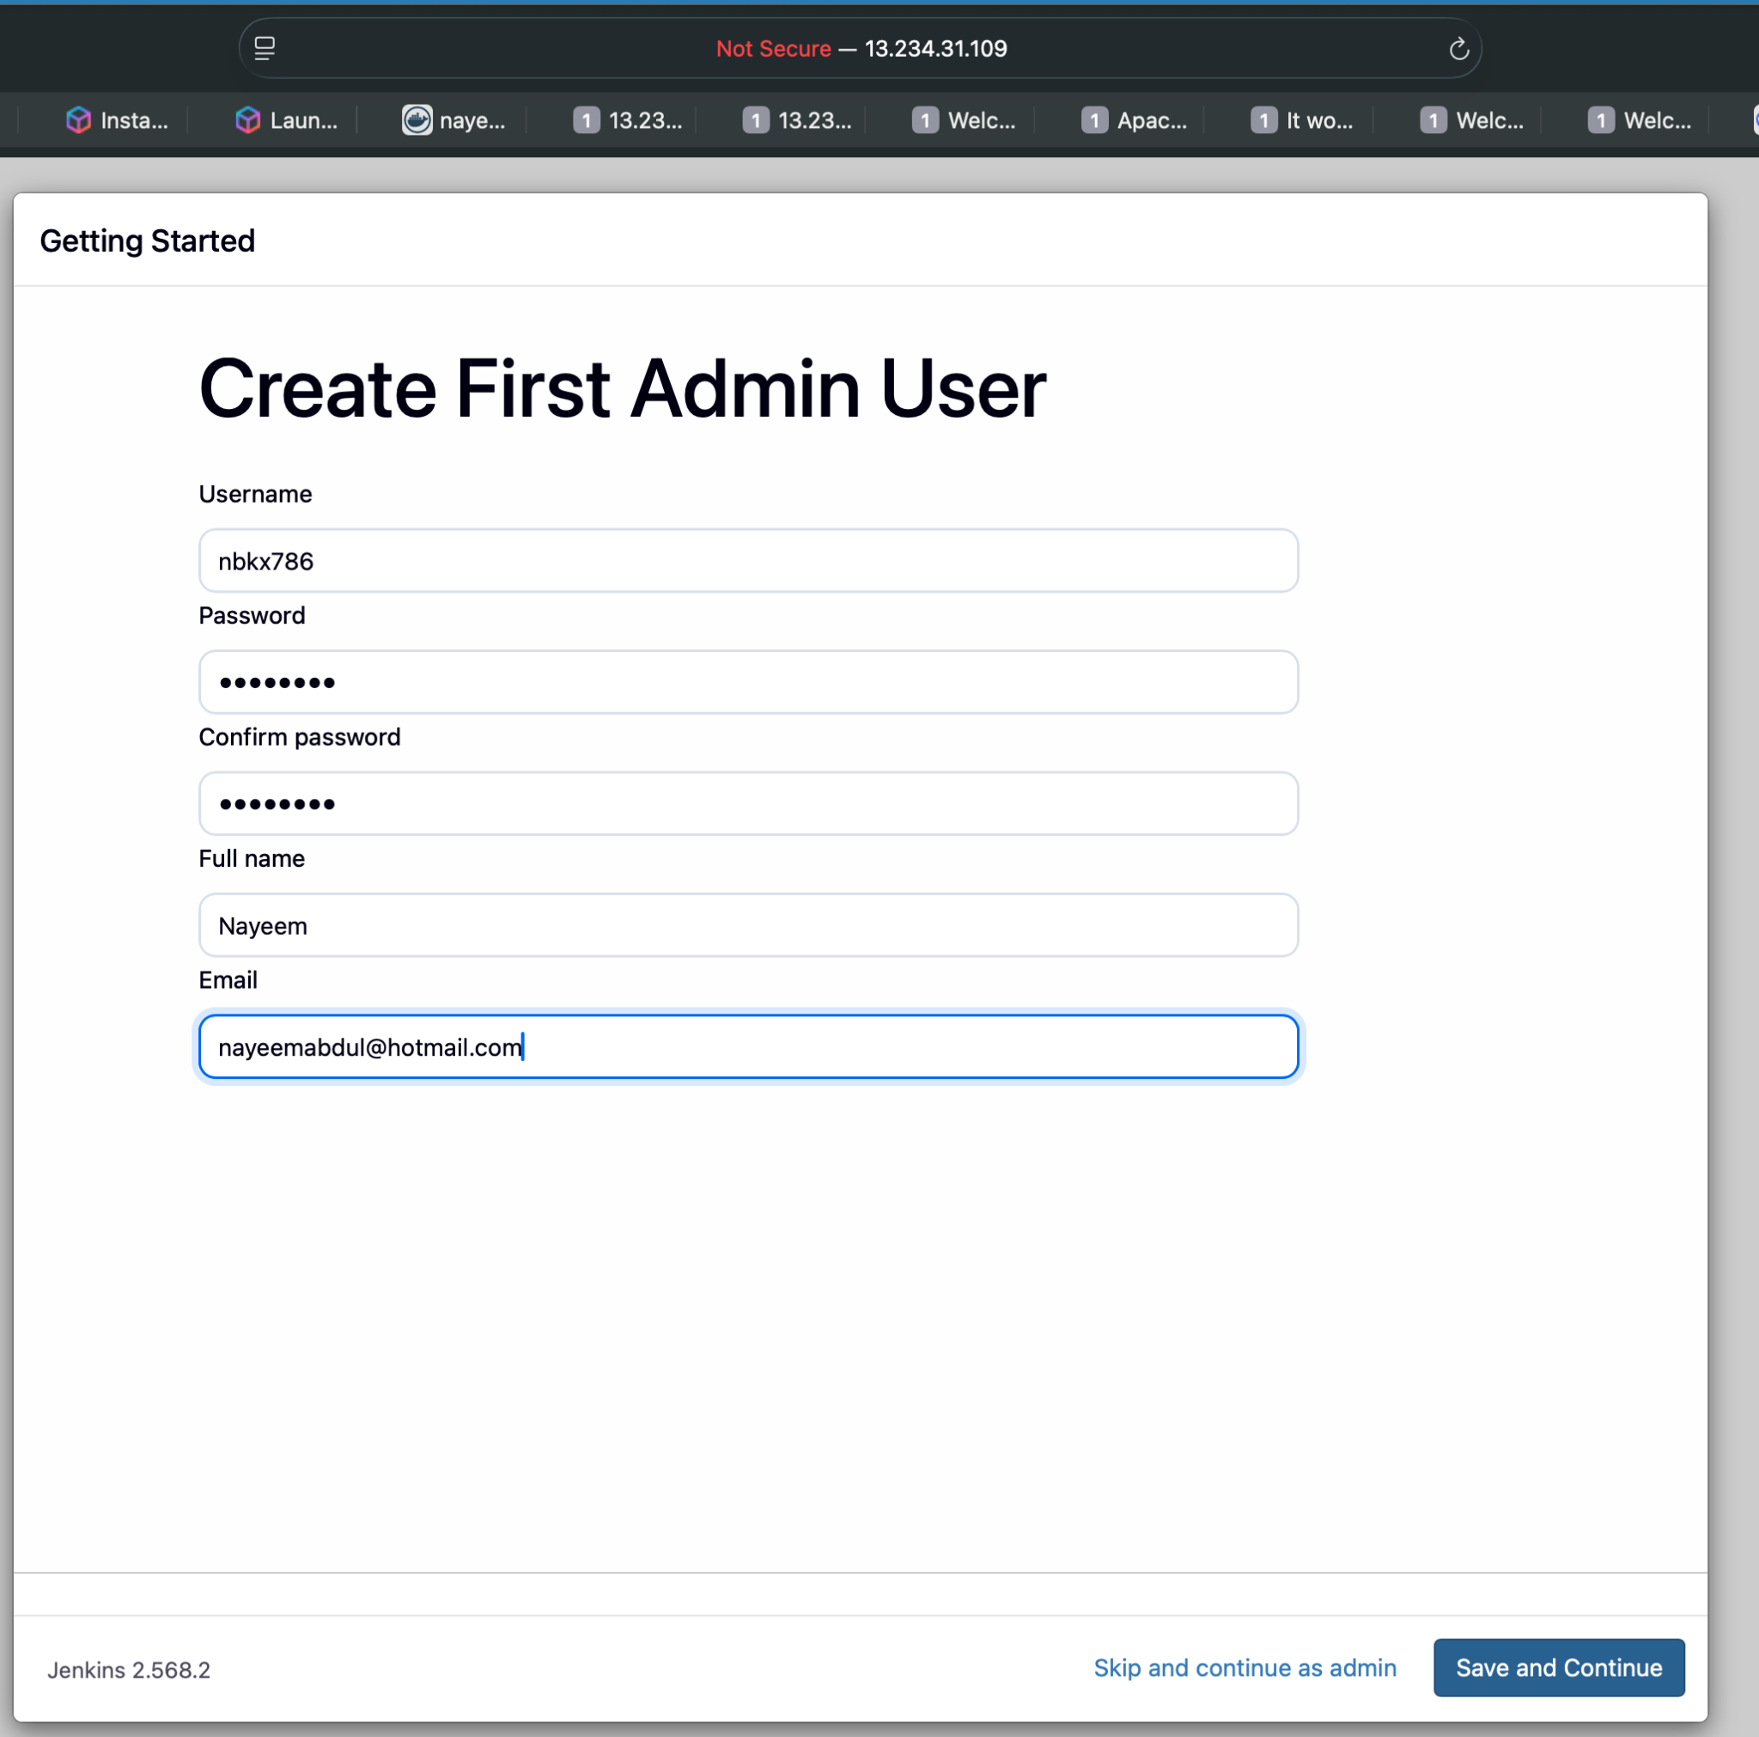
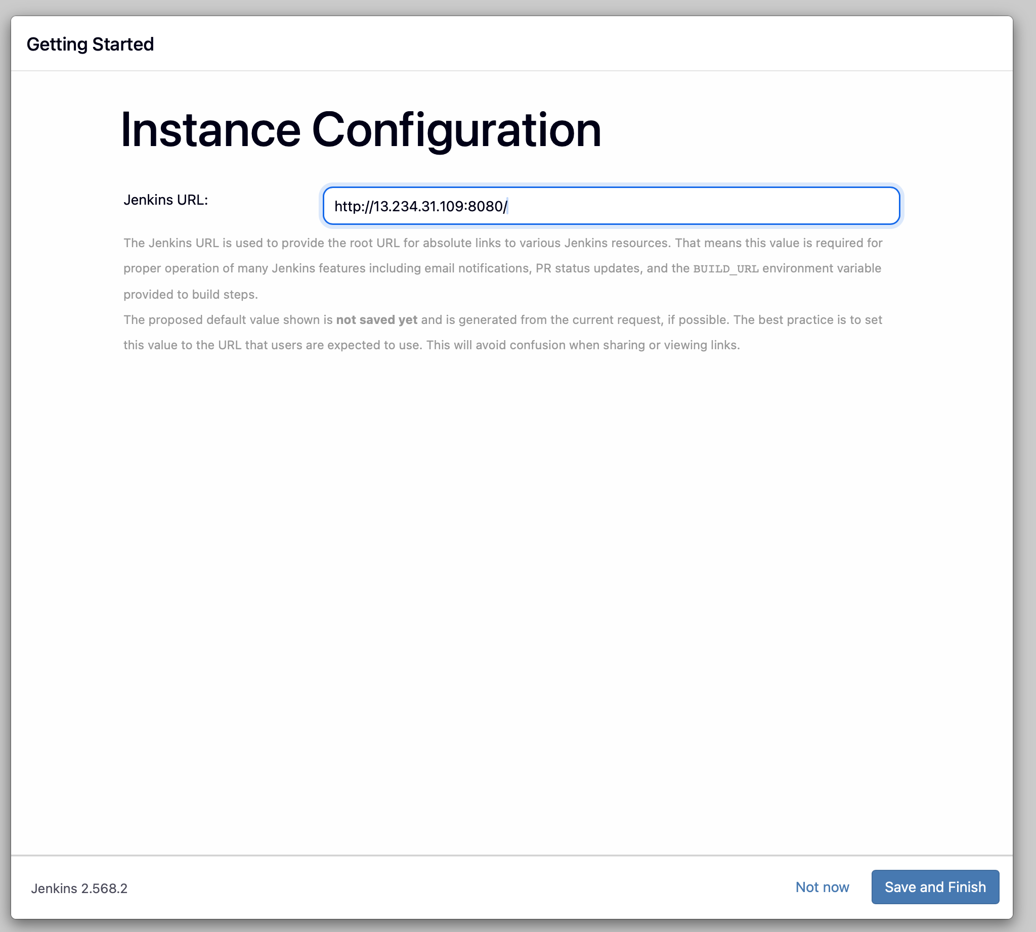
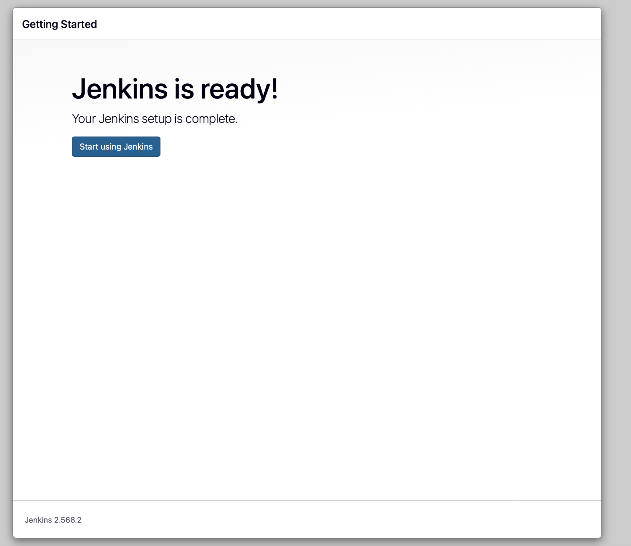
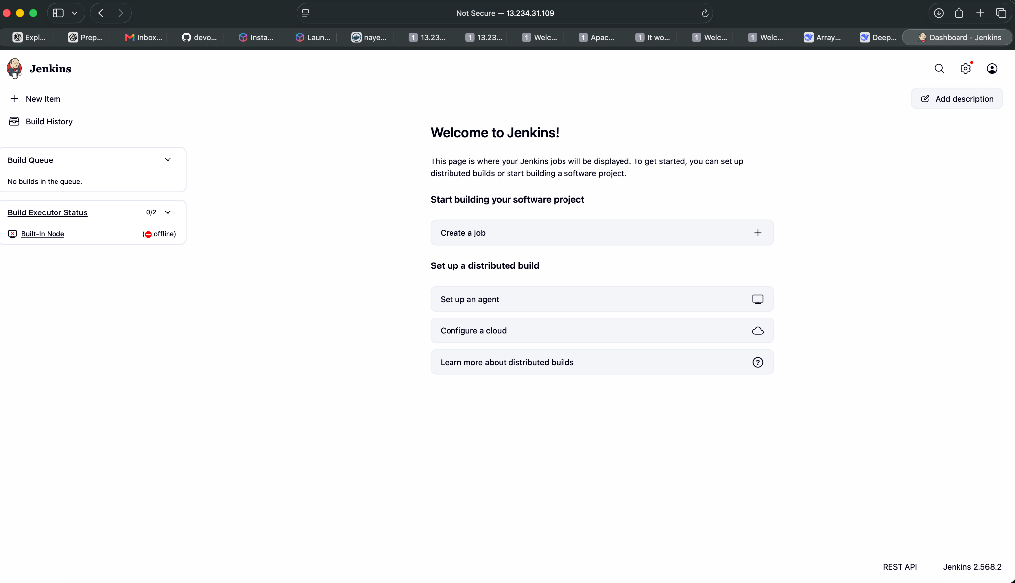

6. Install Apache HTTP Server
Install Apache:
sudo yum install httpd -y
Enable and start the service:
sudo systemctl enable httpd
sudo systemctl start httpd
sudo systemctl status httpd
Create a test page:
echo '<h1>Apache Web Server is Running</h1>' | sudo tee /var/www/html/index.html
Open:
http://13.234.31.109:81
Screenshot Evidence: Apache web page and service status.
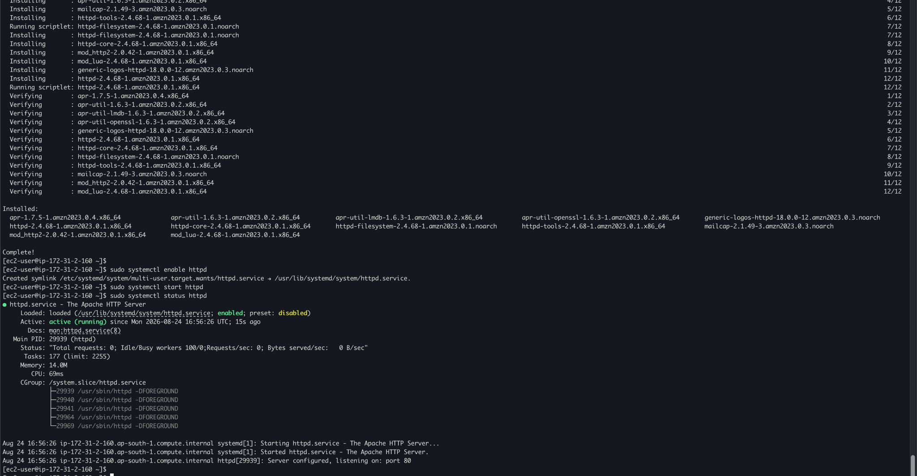

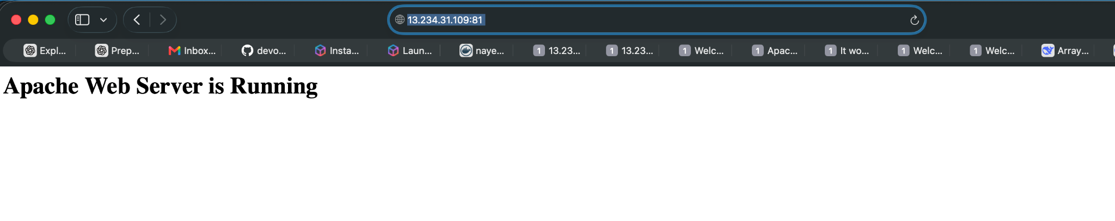

7. Install Nginx
Apache and Nginx both use port 80 by default. Stop Apache before starting Nginx:
sudo systemctl stop httpd
Install Nginx:
sudo amazon-linux-extras install nginx1 -y
Enable and start Nginx:
sudo systemctl enable nginx
sudo systemctl start nginx
sudo systemctl status nginx
Create a test page:
echo '<h1>Nginx Web Server is Running</h1>' | sudo tee /usr/share/nginx/html/index.html
Open:
http://<EC2-PUBLIC-IP>
Screenshot Evidence: Nginx web page and service status.
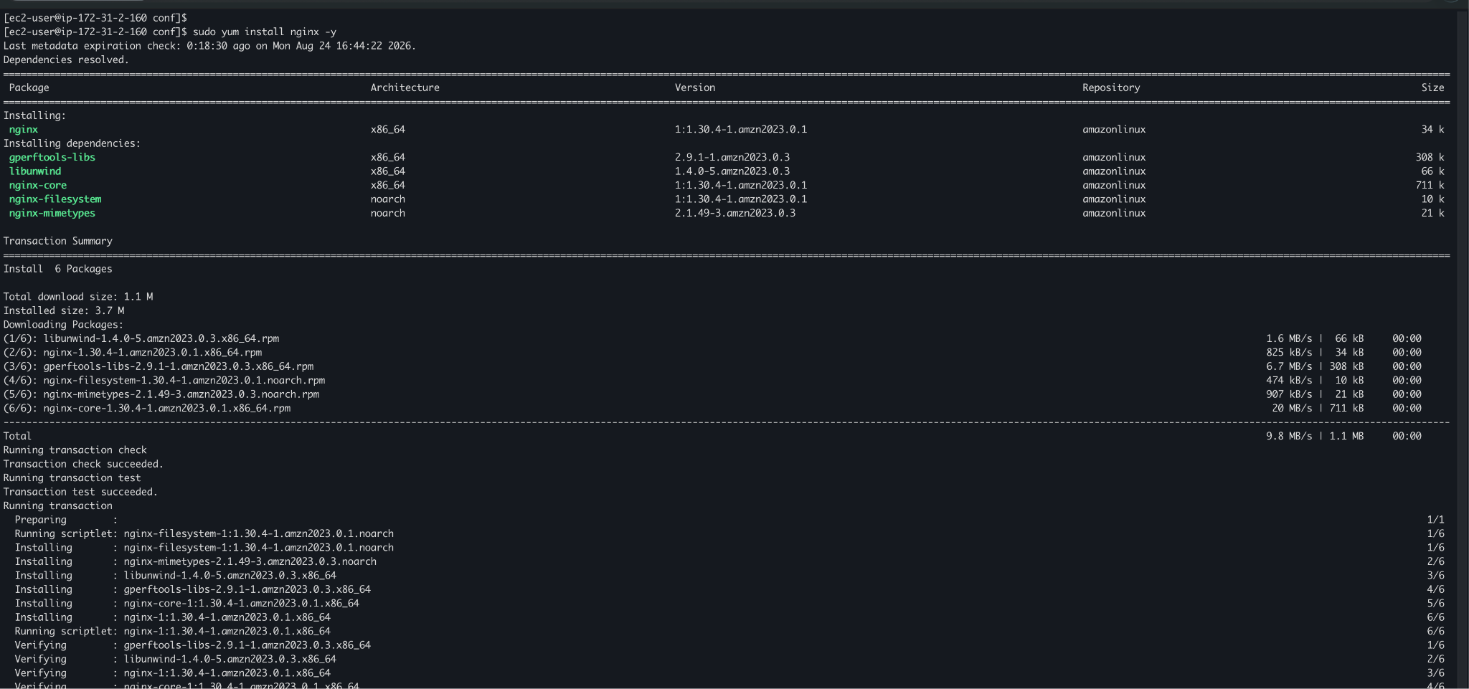
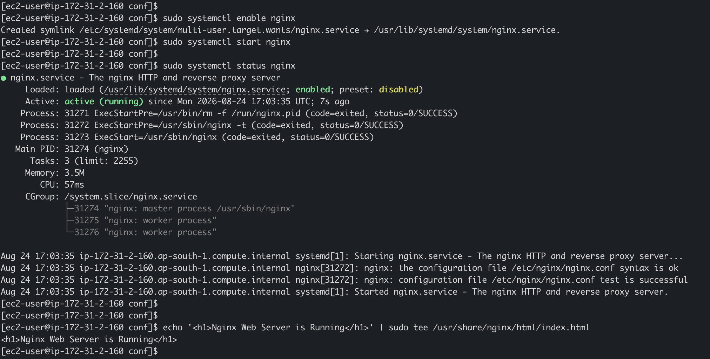
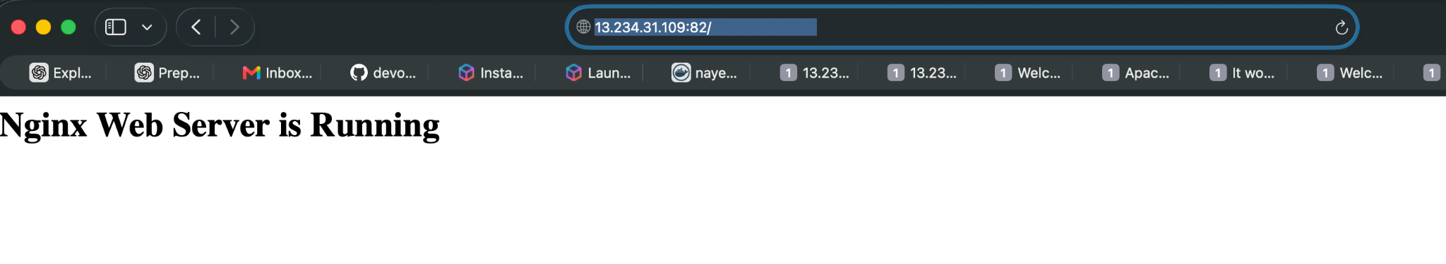

8. Install Apache Tomcat
Download a compatible current Tomcat release:
cd /opt
sudo wget -q "https://dlcdn.apache.org/tomcat/tomcat-11/v11.0.25/bin/apache-tomcat-11.0.25.tar.gz" -O tomcat.tar.gz
Extract Tomcat:
sudo tar -xzf apache-tomcat-<version>.tar.gz
sudo mv apache-tomcat-<version> tomcat
Make scripts executable:
sudo -i
sudo chmod +x /opt/tomcat/bin/*.sh
Start Tomcat:
sudo /opt/tomcat/bin/startup.sh
Verify:
ps -ef | grep tomcat

Tomcat Port
Tomcat normally uses port 8080, which conflicts with Jenkins.
If Jenkins is running on 8080, configure Tomcat to use another port such as 8081 in:
/opt/tomcat/conf/server.xml
Then access Tomcat using:
http://<EC2-PUBLIC-IP>:8081
Screenshot Evidence: Tomcat landing page and running Tomcat process.
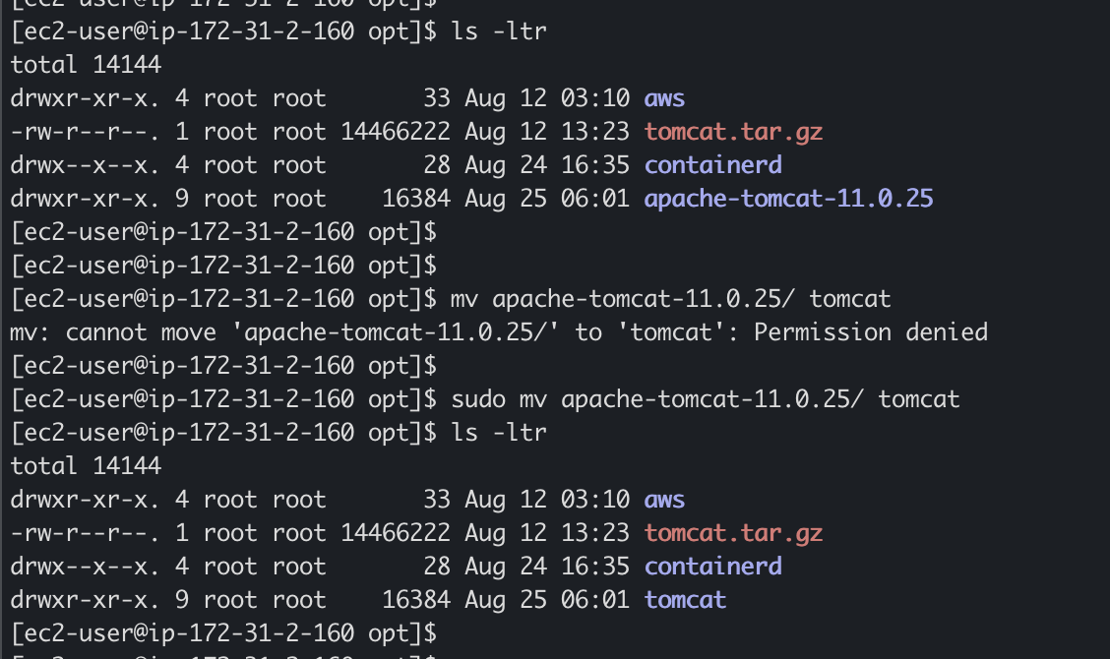
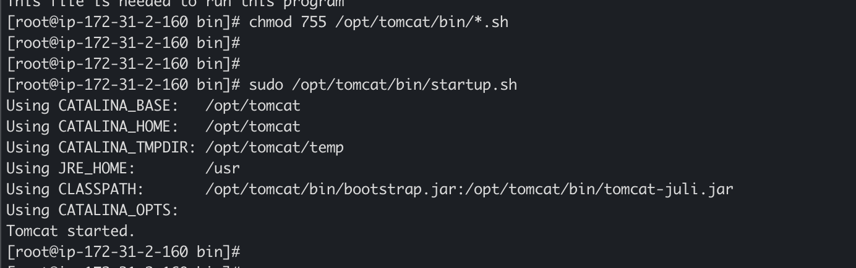
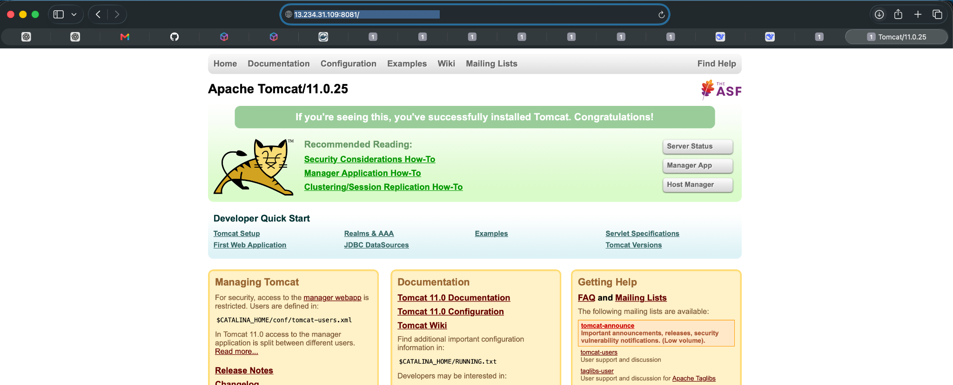

9. Important Port Conflicts
Application | Default Port | Note
Apache | 80 | Conflicts with Nginx
Nginx | 80 | Conflicts with Apache
Jenkins | 8080 | Conflicts with default Tomcat
Tomcat | 8080 | Configure to 8081 if Jenkins uses 8080
Docker | N/A | Container ports depend on published ports

10. Final Verification
Run:
sudo systemctl status docker
sudo systemctl status jenkins
sudo systemctl status httpd
sudo systemctl status nginx
docker --version
java -version
sudo ss -tulpn
Capture the output as assignment evidence.

11. Screenshot Evidence Checklist
- EC2 instance running
- Security Group inbound rules
- SSH connection to EC2
- Docker installation and version
- Docker service status
- Java version
- Jenkins service status
- Jenkins dashboard
- Apache service status
- Apache test page
- Nginx service status
- Nginx test page
- Tomcat process/status
- Tomcat landing page
- Final ss -tulpn output

12. Expected Result
The Amazon Linux 2 EC2 instance should successfully host the required DevOps software components. Docker, Jenkins, Apache, Nginx, and Apache Tomcat should be installed and verified. Port conflicts should be handled appropriately by stopping one web server or assigning applications different ports.

13. Conclusion
This assignment demonstrates practical AWS and Linux administration skills by provisioning an EC2 server and installing commonly used DevOps and web-server technologies. It also provides hands-on experience with package installation, Linux services, systemctl, Java dependencies, networking ports, and application verification.

